# **Template – Financial Aid Verification**

The template named “Template – 2018 2019 Independent Verification Form with DocuSign” is applicable to CampusNexus Student.

## Purpose and Outcome

This template provides a form sequence and supporting workflow for a financial aid verification form. The template simplifies a significant portion of a complete student self-service financial aid verification process as detailed in the attached document **Build Your Own Financial Aid Verification Process**.  


Follow the instructions in the attached document up to **Exercise 1: Create a Financial Aid Verification Form and Supporting Workflow** on page 11. At that point, use the template and refer to the instructions in this document.

When you have completed the template steps, continue with **Lesson 2: Create Workflows to Automate the Verification Process** on page 108 of the attached document.

## Prerequisites

The template was built with Forms Builder using the applications listed below. The template is forward compatible with later versions of the listed applications.

|  |  |
| --- | --- |
| **Application** | **Minimum Version** |
| Forms Builder Designer and Renderer | 3.4 |
| Web Client for CampusNexus Student | 18.2 |
| Workflow Composer | 2.5 |
| Packages installed from Package Manager in Workflow Composer | Activities and Contracts (V1) 18.2.0  Activities and Contracts (V2) 18.2.0  Forms Builder Contracts 3.4 |
| Workflow Tracking Database | N/A |
| Staff STS 2.0 | 2.0 |

## Step 1: Download and Import the Template

1. Download the template file to your environment (local drive or network location).
2. Log into **Forms Builder Designer**.
3. Click the **Export/Import** tile.
4. Select the **Import** tab.
5. Click **Select exported file** and navigate to the downloaded template file.
6. Click **Import**.

* [Export/Import](https://help.campusmanagement.com/FB/3.x/Content/ExportImport.htm)

## Step 2: In Form Designer…

1. From the **Forms** slide out, select **2018 2019 V1 Independent Verification Step 1**.
2. Customize the form for your environment. Modify properties on current fields to make them required, etc., or add/remove fields on form. Make sure you edit the text in the Labels and HTML controls as applicable for your institution and the financial aid award year.

**Note**: In Form Designer, all checkbox controls are bound to one in/out workflow argument called **myDictionary**, which is an array. The workflow will have one argument instead of many for the Model bindings for every checkbox across all the forms. If you modify any checkbox controls, be careful to maintain a unique array index for each item across all forms in the sequence.

* [Fields](https://help.campusmanagement.com/FB/3.x/Content/Fields.htm) and [Components](https://help.campusmanagement.com/FB/3.x/Content/Components.htm)

1. **Save** the form.
2. From the **Forms** slide out, select **2018 2019 V1 Independent Verification Step 2**.
3. Customize the form for your environment and save it.
4. From the **Forms** slide out, select **2018 2019 V1 Independent Verification Step 3**.
5. Customize the form for your environment and save it.
6. From the **Forms** slide out, select **2018 2019 V1 Independent Verification Step 4**.
7. Customize the form for your environment and save it.

## Step 3: In Sequence Designer…

1. Select **2018 2019 V1 Independent Verification Sequence**.

The sequence contains the following forms:

* 2018 2019 V1 Independent Verification Step 1
* 2018 2019 V1 Independent Verification Step 2
* 2018 2019 V1 Independent Verification Step 3
* Default Frame (This form is required if DocuSign is used for electronic signatures.)
* 2018 2019 V1 Independent Verification Step 4

1. Click **Save As** to create a copy of the sequence/workflow and customize the copy for your use. This way you can always refer to the original sequence/workflow you downloaded.
2. Optional - Add a custom style (theme) associated with your campus.

* [Themes](https://help.campusmanagement.com/FB/3.x/Content/Themes.htm)

1. Select your sequence in the Sequences pane.
2. In the Properties Pane:
   * Ensure that the **Authentication Product** is **Student**.

* Select the **End State Form** named **Custom-Confirmation Standard No Auto Close**.

1. **Save** the sequence**.**
2. Open the associated sequence workflow.

Depending on your environment, to open Workflow Composer either click **Open Workflow** in Sequence Designer or launch of a local installation of Workflow Composer.

* [Opening Workflows for Sequences](https://help.campusmanagement.com/FB/3.x/Content/HostedEnv.htm)

## Step 4 In Workflow Composer…

1. Locate the **LookupReferenceItem** activity in the first Form/State and verify that the **Independent Verification Form** is found in your environment.

The template assigns the following values to the activity. Modify the values as necessary for your environment:

* + - * Display Name: **Find Document**
      * Reference Item Type:  **Document Type**
      * Reference Item: **Verification for Independent**
      * Reference Item Id: This is the Id of the document selected above and will auto populate.

1. In the transition after the **Default-Frame** state, in the **CreateDocument** activity, verify that the **Document Status** is applicable for your environment.

Note that the status value is set in both branches of the **If** condition (“If document exists”). Where the value is already found (not created), the value is hard-coded.

Use a Lookup Reference Item activity to find the correct status value for your environment. Simply drag/drop the **LookupReferenceItem** activity into the workflow. Select the **Type** you are looking for (e.g., Document Status) and then select the Item you are looking for within that.

The document status for all documents in this process will be Ready for Review. The activity will return the hard-coded Id value (e.g., 13).

* [LookupReferenceItem activity](https://help.campusmanagement.com/WF/Content/Workflow/LookupReferenceItem.htm)

1. In the same transition after the **Default-Frame**, check and set the **Task Type** value appropriate for your environment.

Again, use a Lookup Reference Item activity to find the correct Task Type value for your environment.

1. In the Final transition, check the **CreateDocument** activities for each document uploaded and verify the **Document Type**. If desired, you can specify the Document Type for all items as “Verification Document”.

## Step 5: In Forms Renderer and CampusNexus Student…

Select your sequence and try it out! Go ahead and add the Verification for Independent Document to your student as “Requested Required”.

* [Sequence List](https://help.campusmanagement.com/FB/3.x/Content/SequenceList.htm)

1. Find your **Verification** sequence and copy the **URL** to the clipboard.

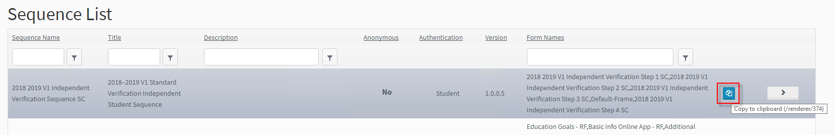

1. In CampusNexus Student, verify the staff member was notified to complete the Verification Process.

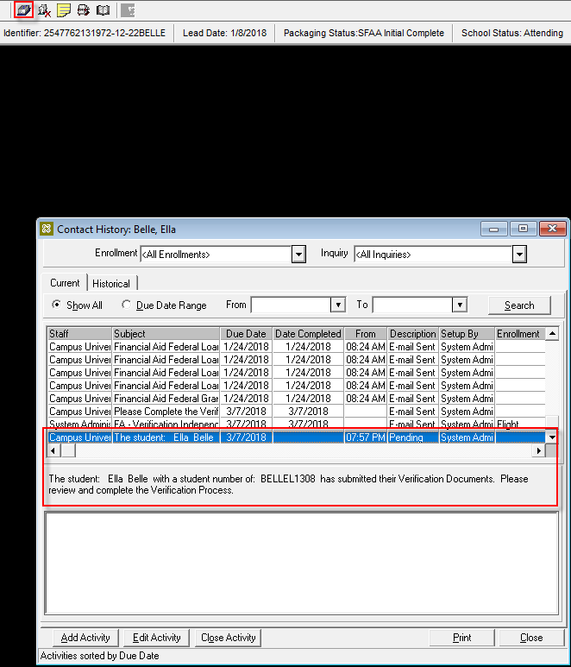

1. In **CampusNexus Student Desktop Client**, navigate to **View> Contact Manager > Activities** and confirm that the Verification for Independent Document is “Ready for Review” and any additional Verification Documents have been added to the Document Center for the Student as “Ready to Review”.

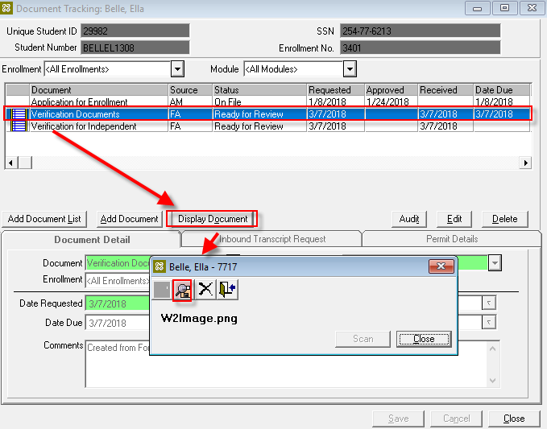

At this point the form only updates the Verification for Independent Document, adds the Verification Documents, and notifies a staff member.

The process to trigger the document to the student is as follows:

1. The import of an ISIR will trigger the Verification for Independent document to be added to the document center for the student as Requested Required.
2. The adding of the document triggers another workflow to send the link to the student.
3. The student will click on the link and complete the form.
4. The Verification for Independent document will have the PDF attached and status updated to Ready for Review, and any other Verification Documents uploaded will be added to the document center in the same status.
5. The Staff member will be notified to complete the verification process for the student.

Test the sequence for a student who does not have a verification form on file and uploaded multiple verification documents. Also test the sequence for a student who already had a verification form on file.

## Step 6: Lastly…

Once your updated sequence has been tested successfully, it is recommended that you disable the workflow for the original Template version.

1. In Workflow Composer, in the Server section of the ribbon, click **Open**.
2. Find the workflow named **Template – 2018 2019 Independent Verification Form with DocuSign**.
3. Clear the **Enabled** check box and click **Save**.

Continue with **Lesson 2: Create Workflows to Automate the Verification Process** on page 108 of the attached document to complete the remaining steps of building and testing the FA verification process.

